ICS344 - Information Security – Section 4

Student Name(s) + ID(s):
Abdulwahab Badirah 202160410
Yazed almutairi 202164390
Abdulmuhaymin Althabit 202275600
Mohammed Alfaraj 202323090
DVSA Website URL:
http://dvsa-coptrz-sec-2026-157282994461-us-east-1.s3-website.us-east-1.amazonaws.com/
AWS Region: N. Virginia (us-east-1)
Date: 5/3/2026
Vulnerability Title(s):
Lesson 9: Vulnerable Dependencies

Lesson 9: Vulnerable Dependencies
- Goal and Vulnerability Summary
This lesson demonstrates a Vulnerable Dependency in the DVSA application. The affected component is the DVSA-ORDER-MANAGER Lambda function, which uses the node-serialize library to process user input. This library allows unsafe deserialization of attacker-controlled data. The impact is severe, as it enables remote code execution (RCE) inside the Lambda environment.

- Why This Works / Root Cause
The vulnerability exists because the application uses:
serialize.unserialize(event.body)
This function executes serialized JavaScript functions contained in user input. Since user input is not validated or sanitized, an attacker can inject malicious code that is executed during deserialization.

- Environment and Setup

- AWS Region: us-east-1
- Service: AWS Lambda + API Gateway
- Function: DVSA-ORDER-MANAGER
- Log group: /aws/lambda/DVSA-ORDER-MANAGER
- Tool used: curl (CMD)
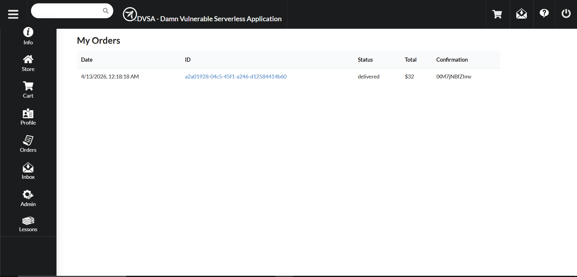

User successfully logged into DVSA.
Application is accessible and functional.

- Reproduction Steps

- Open API endpoint /order
- Send malicious payload:
curl -X POST "https://5zga32to6k.execute-api.us-east-1.amazonaws.com/Stage/order" ^
-H "Content-Type: application/json" ^
-d "{\"action\":\"_$$ND_FUNC$$_function(){console.error('LESSON9_TEST_SUCCESS');}()\"}"
- Check CloudWatch logs

- Evidence and Proof
API Response:
{"message":"Internal server error"}
CloudWatch Log:
LESSON9_TEST_SUCCESS
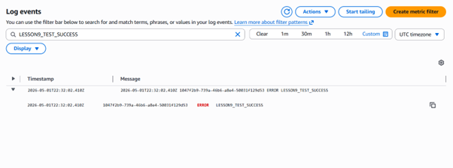
This proves attacker-controlled code executed inside Lambda.

- Fix Strategy / Probable Mitigation

- Remove unsafe deserialization (node-serialize)
- Replace with safe parsing (JSON.parse)
- Validate input before processing
- Reject malformed input

- Code / Config Changes
BEFORE:
req = serialize.unserialize(event.body);
headers = serialize.unserialize(event.headers);
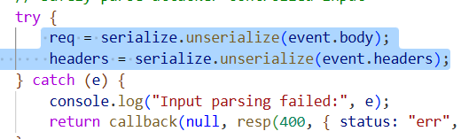
AFTER:
req = JSON.parse(event.body);
headers = event.headers;
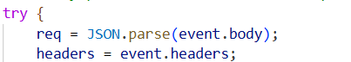

Removed:
const serialize = require('node-serialize');

- Verification After Fix
Re-run exploit:
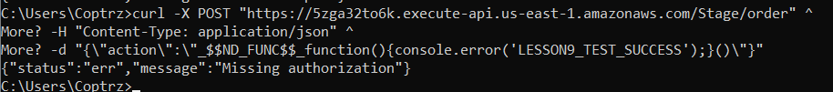
Result:
{"status":"err","message":"Missing authorization"}
CloudWatch:
No events found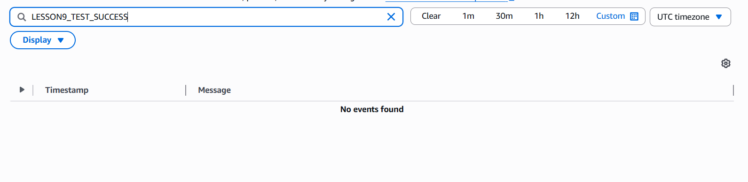
No execution → vulnerability fixed

- Structured Analysis
Table A
Vulnerability | Intended Rule | Evidence | Normal | Exploit
Vulnerable Dependency | Input should not execute code | CloudWatch logs | No execution | Code executed

Table B
Vulnerability | Deviation | Class | Fix | Verification
Vulnerable Dependency | Unsafe deserialization | Security misuse | Remove node-serialize | No execution

- Takeaway
This lesson shows that using unsafe third-party libraries can introduce severe vulnerabilities. Proper input validation and avoiding dangerous deserialization functions are critical in serverless applications.

